DIB STARKLINE STATEMENT DD 12 TO 13.07.21
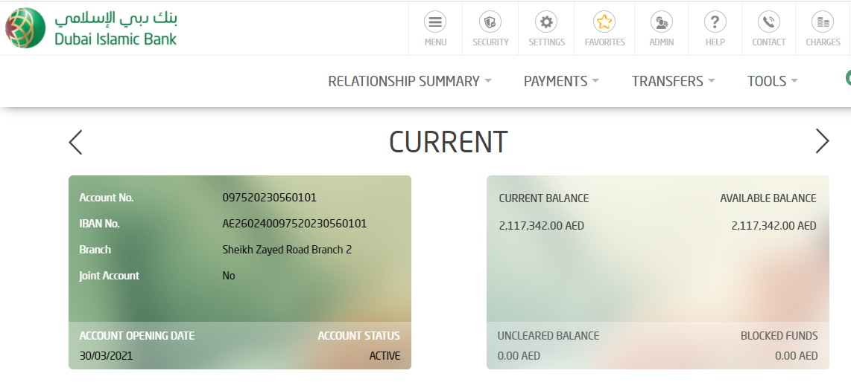

EURO
