DIB STARKLINE STATEMENT DD 16 TO 17.03.22

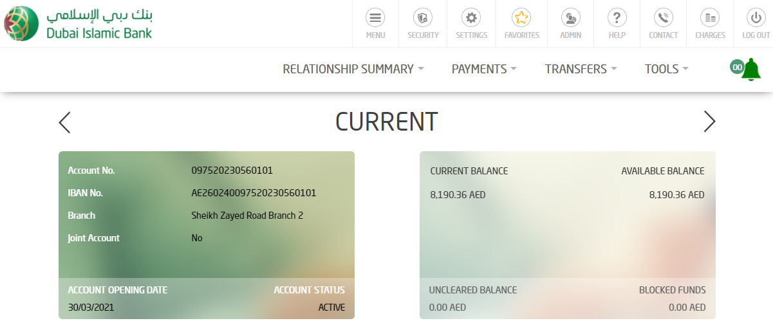

EURO

